Don’t Fall Overboard!
By Noel Parry
Jackie and I have always considered the most important safety consideration onboard a vessel is the maintenance of Watertight Hull Integrity. Then the subject of Man Over Board comes up and the term itself opens a whole can of worms. Just what is the most important safety consideration on your boat?
Consider this: having the vessel maintained in pristine ocean going, tip top condition means diddley squat, if you are watching that fine craft sail over the horizon whilst treading water.
Well, I reckon I’d rather eat that can of worms than to ever have to face the real onboard emergency of a MOB. And that is regardless of my position in the drama, whether I’m in or out of the water a MOB situation will ruin your day something shockin’ or possibly the end of someone’s life, maybe yours.
SOLUTION: DON’T FALL OVER BOARD!
When you are in a boat, on the water underway, in any situation, your prime objective is to stay on the boat. It’s that simple. It is also, oh so simple, to find yourself bobbing in her wake.
Wear a harness and clip on. This includes when in the cockpit, shorthanded and your partner is off watch below. Jackie and I could not sleep until we had called out to the other, ‘Click, Click’. In other words, we wanted to hear the other verify that they are clipped onto the harness and onto the deck, ‘Click, Click’. Both carbines of the tether have to be locked on. The thought of waking, only to find an empty boat, inspires ideas and the practice of prevention. Despite all the scenarios of MOB practice and drills, the awful prospect of failure is always a possibility. When would you stop searching and how do you prevent a lifetime of, ‘if only I’d…’ or ‘what if we’d done…’ etc.
The boat at sea is your only universe. Hang on, for their sake!
TACTICS
It’s down to you and only you, to be involved with training, study, and practice techniques that suit your vessel. I.e. the vessel you are on at the time. It’s no use knowing how to turn about your 10 metre Halverson cruiser, if you are currently on Wild Oats XI surfing down waves at 25 knots.
We have all performed standard MOB drills, invariably in calm waters and with a crew of eight brimming hopefuls. Here’s how they normally go:
1. ‘Man Overboard’ cries the dutiful and prospective sailor, maintaining a visual on the floating ‘dummy’ (usually a MOB flag named ‘BOB’)
2. The rest of the crew raise the alarm, ‘Man Over Board’
3. One of which may go below and carry out a mock radio ‘Pan Pan’
4. You, the helmsperson acting as skipper and being assessed, hit the MOB button on the helm mounted GPS
5. You then ask the f’ward hand (if sailing) to furl the jib, as you turn the wheel, rounding the boat up and having the crew (if they don’t mind), pulling on the mainsheet, dropping the main and maintaining a visual on BOB
6. Check there are no lines in the water. (Getting the crew to verify that of course.)
7. You then start the engine (or probably just put it in gear, as it has been running all day) and putter up to BOB, slip into neutral and keeping BOB to leeward, coast alongside and casually have yet another crew member retrieve the 4kg flag with its inbuilt pick up stick. All good, no dramas and the only complaint comes from the rescuing crew member copping some salt water dribbling off BOB.
All of this establishes that the crew has the wit to realise the importance of raising the alarm, maintaining visual on the MOB, marking BOB’s position on the GPS, how to round the boat up in calm sheltered waters, check for lines in the water, and of course picking up BOB under motor. All good boat handling practice and a good start.
REALITY: The following are just some ideas to start you thinking of tactics you can employ, they are only a guide. You must develop and practice MOB procedures that suit you and your boat. And just to be really mean, try day and night retrievals, they are different, both have disadvantages/advantages. Good Luck!
Scenario: Jane and John are on their sailing yacht ‘Just Once’, crossing the Pacific. Latitude 18 deg South. Bound for Fiji. Course currently 270 deg. True.
Wind, south-easterly 20-25 kts true, on the port quarter, main and genoa to leeward, staysail to windward (the genoa is on a furler and the staysail is hanked on, both headsails are poled out, Jiffy reefing main has a single reef with the preventer on). The seas are building 2-3m on a 2m swell and are considered by the crew as normal trade wind sailing.
The two-handed crew are happy enough with the conditions, having left port three days ago, they are settled into a routine and enjoying six hour watches. All is well onboard.
Jane wakes on day four to find no sign of John, she has heard him only 30 mins ago as he muttered about the ‘the bloody stays’l needs to come in,’ and his footsteps overhead on his return to the cockpit, she had, thinking all’s well and gone back to sleep.
‘Where the bloody hell are you, John? Bet he’s on the dunny, bloody bugger better not be?’
JOHN ISN’T, AND HE IS NOT ON THE BOAT, WHAT DO YOU DO?
GUIDELINES: Things to think about, refine and/or change completely to suit you.
Hit the MOB button on the GPS, from that position Jane can work out John’s approx. position later.
RAISE THE ALARM via the radio (hitting the EPIRB button is an option)* This will activate Search and Rescue, you can issue a PAN PAN or MAYDAY verbally when you get a chance (or cancel the alert if all goes well).
Raising the Alarm quickly is critical as you may not be able to contact later. I.e. you may have become a casualty yourself.
Note known data: time John went overboard, current course., speed. The current position is recorded on MOB function as well as on GPS ‘boat track’ (If turned on. We leave boat track on all the time, generally, it’s a very handy bit of kit).
Get the head sails furled, dropped. A furling Genoa should be rigged so as to allow furling to occur with the spinnaker pole still attached to the sheet. (When furled the pole comes in tight (ish) to the forestay, downhaul, and topping left can be left in position/adjusted/tightened as required. As with everything, practice in good conditions to perfect this). The Staysail can be dropped, luff lashed down with lanyard, sheets pulled and cleated in taught.
Round up into wind (tacking, avoid the added strain and time taken to gybe) using the Windvane steering or Autopilot, easing preventer as you go. Tighten main amidships for now. With jiffy reefing it should be possible to reef under any point of sail but as you were previously heading down wind and now have to head into the wind and waves, you may as well round up. And get other stuff sorted first.
Check that no lines are in the water.
Start engine, take a breath, ascertain all is good, calm the adrenalin, you can do this, you can save John.
Check wet exhaust if fitted and/or raw water intake is open. Check engine gauges are good to go. Fuel tap on.
Disengage windvane
Engage engine forward
Engage Autopilot
Set reciprocal course
Manage mainsail, may need further reefing to prevent excessive heel whilst motoring
Give the engine some wellie, it’s not a practice run now and diesel engines love to work hard
Breathe (you must ensure you don’t injury yourself or become an additional emergency event).
Wind and waves should now be fine on the starboard bow, the motion will have increased in severity, having the main up will also help with drive and stability under motor. Should the Course to Steer (CTS) be right on the nose, veer off sufficiently so as to enable the main to work and not luff (not too much anyway). You may have to tack your way up to the estimated MOB position. That’s OK, your speed, motion, and safety will be better than directly banging dead on into the wind and sea.
Now you have some time. Work out where John is by using the plotter and/or paper chart and known last position and using previous course and speed, plot backwards. Even with ‘boat track’ you have to figure out where abouts on the track the MOB fell in. Mark this as WP2 (waypoint).
From WP2, the surface sea current and wave action has certainly moved the target (John) in the time elapsed. Time elapsed already may be an hour and may take a further 3-4 hrs to get back to him.
Estimate Johns maximum set and drift over 4 hours (probably at drift rate of at least 0.5-1 knot, i.e. 2-4 nautical miles over 4 hours. Scary eh?). Mark this position at 4nm in the set direction, as WP1.
Head for WP1 which will be closer to John’s current position.
At WP1 head for WP2 and still using ‘boat track’ record search pattern. John is hopefully somewhere between WP1 and WP2.
With the boat on course to WP1, RAISE THE ALARM manually, use the Satphone if you have it, VHF or HF radio or all three until you get a response and have the time to do so.
PAN PAN, or MAYDAY, Both are monitored and acted upon as an Emergency.
Example:
PAN PAN, PAN PAN, PAN PAN, THIS IS THE SAILING VESSEL ‘JUST ONCE’, ‘JUST ONCE’, ‘JUST ONCE’, IN POSITION 18 DEGREES 24 MINUTES SOUTH, 165 DEG 50’ WEST. MAN OVER BOARD AT ESTIMATED POSITION blah,blah,blah. One POB, continuing search. OVER.
LISTEN FOR RESPONSE
RESPOND AND/OR REPEAT
Get something to eat and drink, as well as warm clothing. This is important while you have time. At John’s estimated position you will be on constant watch and retrieval.
Check fuel level in tank, it may take 3-4 hrs to return. Depending on boat’s capability. You may decide, now that you have control back on board and can re-assess the situation, to sail back close hauled. It can be a preferred/faster option or not.
YIPPEE! You find John as he has an inflatable mast and flag (danbuoy) which gave a good visual OR a Strobe Light (which are brilliant day and night) and/or you had previously both fitted MOB EPIRB’S, with locatable tracking from your boat, or similar. Otherwise in reality the chances of seeing John’s head in even these moderate to fresh conditions is very unlikely.
You’ve found John. Now you have to get him onboard. Another can of worms!
Deploy the practiced techniques you are familiar with. Is there a retrieval system onboard? If so, where is it? How do you rig it? (You’ve completed the SisterShip Training Emergency Preparedness Workshop, so, phew! You know all this and have it all prepared!)
STOP ENGINES (engage neutral) before you get too close to John.
Assess your drift and boat motion. You do not want to slam down on top of the git just when you have the chance to get him onboard and strangle the #%$@@.
When John is safe on board, take the time also to assess: how hard do you slap him for not CLIPPING ON!

*This is just one option. In our Emergency Preparedness manual we’ve detailed the other, more usual, options: DSC alert, Radio call, etc. During an emergency you should first try to communicate with others using radio, phones and signalling devices.
We’ve included the EPIRB option here as an idea depending on your equipment capability (e.g. severe weather has hampered other equipment). An EPIRB alerts authorities to a distress. If someone is overboard and hasn’t been seen, the likelihood of ever finding them again is extremely small. This is a distress situation.
Scenario names are fictional, not directly related to any specific incident or persons/boat and the boat handling is based on a long keel, 11 metre, heavy displacement boat.
Advice from AMSA
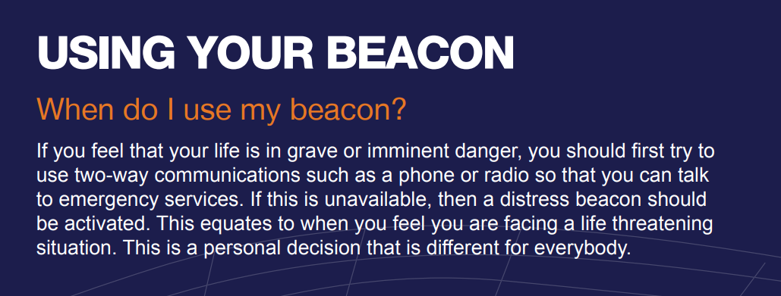

Equipment information accessible on this webpage:

This link from Marine Safe Australia Pty Ltd shows how an integrated lifejacket AIS beacon works.
This beacon claims AIS contact plus sending an alarm to your VHF with DSC capability up to 5nm. For sale readily in Australia from several sources.
Similar, made in France, AIS contact, does not mention DSC Alarm though. For sale through SIMY, UK and France online.

