LOSS OF PROPULSION PROCEDURE
In the event of posing propulsion: Location:
1.

2.

3.

4.

5.

6.

NOTES:

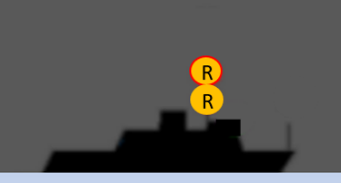
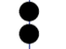
Col Regs
Not Under Command:
Night time
2 all-round red
vertical lights
Day time
2 all-round black
vertical balls

