Bilge System
A bilge system removes unwanted water and liquids from within the vessel in order to maintain its reserve buoyancy and stability.
We have to give more consideration than just pumping small amounts of water, for example if we are fire fighting by pumping in water, we have to ensure we can pump out the same volume of water.
Shared bilge/fire systems are common in small vessels. Reliable equipment and alarms are vital, particularly in the engine room where water ingress may stop the engine, the power supply and the pumps!
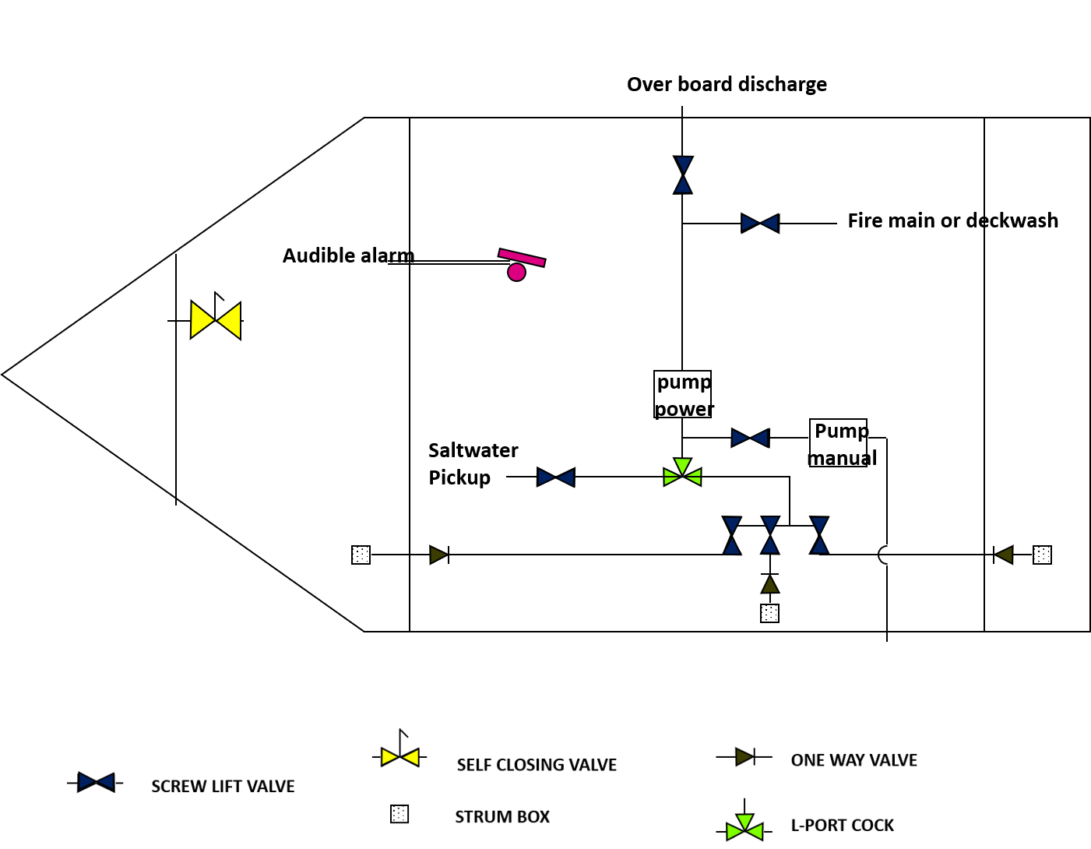

Diagram notes over page:

Vessel fitted with:
- A fire main/deckwash
- One power pump and one manual pump
- Bilge level device with an audible alarm for engine room space
- Valves on sea water pickups
- Independently valved bilge lines
- Strum boxes or strainers on bilge pickups
- One way valves or L-port cocks to avoid backflooding
- If a watertight compartment is small volume it may be drained into the next compartment by means of a self-closing valve (commercial vessels = 7% of underdeck volume)

