Types of turns for POvB / MOB
There are different ways to turn your vessel around. You must consider the conditions, whether you have sails up (if a sailboat, see manual details), and your boat’s handling limitations.
The priority in the first instance is to manoeuvre the propellor away from the person in the water.
The 'Y' turn method
Turn the helm hard over (in the direction of side person went over)
Stop engines and apply full astern propulsion (with helm still hard over in same direction then full ahead with helm still in same place)
Slow and straighten near to person in water, stop near person.
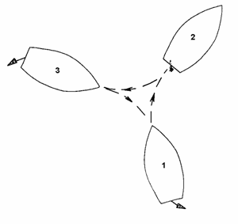
The Elliptical Turn
Upon hearing ‘MOB’ the helmsperson turns the wheel hard over on the direction to the side which the person fell overboard. Quickly noting the compass course prior to turning.
Keep the wheel hard over until the vessel is on the reciprocal course (course + 180°).
Once on the reciprocating course, straighten up and until 30° past the person in the water (as per the diagram below).
Then turn the wheel hard over in the same direction as before until back on the original course.
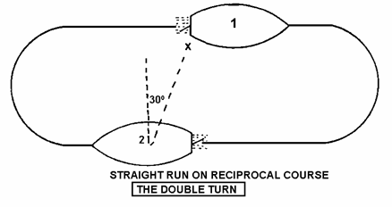
The Williamson's Turn
Turn the wheel hard over in the direction to the side which the person fell overboard. At the same time they should note the compass course they were on prior to the turn.
The wheel should be kept hard over until the vessel is 60° from the original course.
Then put the wheel hard over on the opposite direction until the vessel is on its reciprocal course.
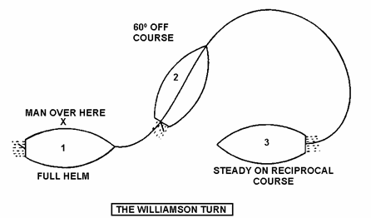

Searching for a Person Overboard
Expanding square system
This system starts at a point closest to where the person was observed, original mark on the plotter would be used. The pattern is shown in the image below.
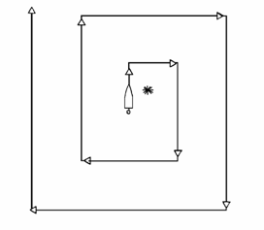
The distance between the tracks will depend on
height of lookout and weather conditions.
Each sweep should double up on detection.

Sector searching
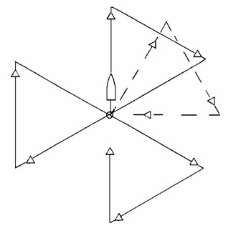
The sector search pattern can be used if the incident position was noted and the conditions indicate that the person may not have drifted far. All changes in course are 120° to starboard.

If the person has not been detected on
completion of the first search, adjust
the original line by 30° and recommence
the search pattern.
Distance for each leg will vary for types
of vessels but may be 1-2 nautical miles.

