MOB Retrieval
The first section contains excerpts from: SOLAS regulation III/17-1. Resolution MSC.346(91). Additional information is at the end of the document.

If you go overboard your chances of recovery are somewhere not far below 50%.
If you are overboard and not been seen, the chances are you will not make it. Improve your chances by having the right gear, wearing it, understanding how it works, and carry out drills.
Person-in-the-Water Recovery
“MAN OVERBOARD!” is one of the worst alarms to hear while underway.
Decisive action is of primary importance when a person falls overboard as even the best swimmers can become disoriented when unexpectedly falling into the water. Prolonged exposure to rough seas or cold weather can quickly weaken a swimmer.

Section A. Recovery Methods

Introduction
All crewmembers must be prepared when someone falls overboard. Rehearsing how to react is vital to a successful and safe recovery of the individual. When someone falls overboard, crewmembers should always assume the worst has happened. The person could be suffering from shock, may be unconscious, and possibly injured. Rapid recovery of the person is a must.
The information here is a general guideline. Actual situations will vary and all details pertaining to each are beyond the scope of this publication. A professional understands and researches each possibility relevant to their situation. Remember that the key to a success rescue is planning, preparation, and practice.
There are two basic approaches:
A leeward approach (against the wind and current).
A windward approach (with the wind and current).
The condition of the person in the water (PIW) will dictate the type of recovery procedures used. Once the condition of the PIW can be determined, that is, conscious, unconscious, or injured, the coxswain will select one of the procedures below and assign crewmember duties accordingly. Generally, the pickup is completed at the lowest point of freeboard and away from the propellers.
Training boat crews for Person in the Water Recovery requires the use of a life-like dummy (OSCAR). The recommended OSCAR is a stuffed and weighted (approximately 180 lbs dry (85.5 KG)) Anti-Exposure Coverall secured at the neck and feet.
Uninjured and consious
Perform the following recovery method when the person is conscious and able to move freely in the water:

Step | Procedure
1 | Upon command of the coxswain, a crewmember casts out a heaving line or a float line to the PIW.
2 | The person will hold onto the line and be hauled in for recovery by the crewmember tending the line.
3 | If the person needs assistance to board the boat:  Two crewmembers could be used to pull the person up out of the water and onto the boat by each placing a hand under the person’s armpit (use the other hand to hold onto the boat);  or  A recovery strap/piece of line (see Figure 16-9) or a boarding ladder may be used if available.

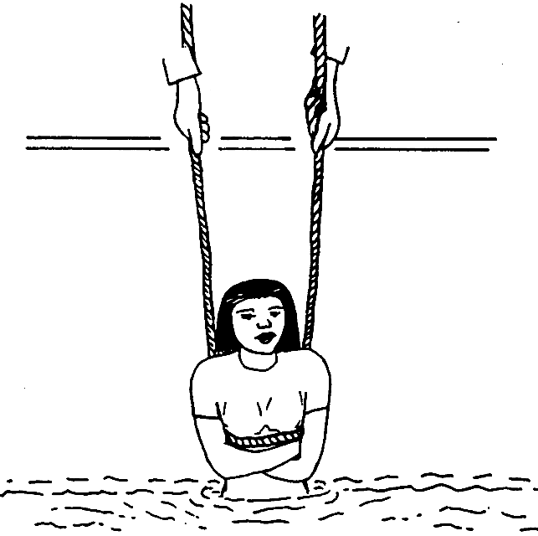

Figure 16-9
Recovering a PIW with a Recovery Strap or Line
The construction of some boats allows the rescue team to reach the victim at the surface of the water.
The boat crewmembers should physically pick the person straight up out of the water to a sitting position on the gunwale (gunnel). (see Figure 16-10)
Be careful not to drag the person’s back across the rail.
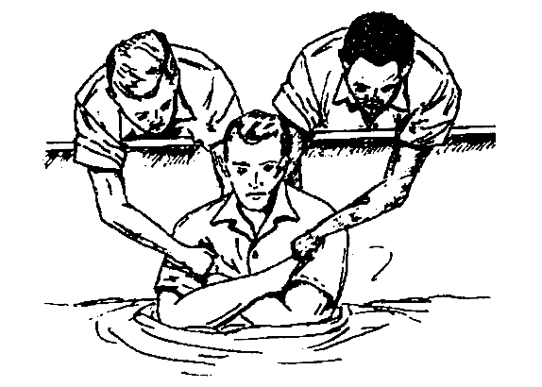

If only one person is available to lift an uninjured person from the water, perform the following procedures:

Step | Procedure
1 | Position the victim facing the boat with both arms reaching upwards.
2 | Boat crewmember should reach down with arms crossed and grasp victim’s wrists.
3 | Boat crewmember should lift the victim straight out of the water while simultaneously uncrossing the arms. This should extract the victim from the water in a corkscrew motion.

If the freeboard of the boat is too high to recover the victim safely, perform the following procedures:

Step | Procedure
1 | Use a rescue strap/line under the armpits in a horse collar fashion. (see Figure 16-9)
2 | The line should cross the chest, pass under each arm, and up behind the head.
3 | Use padding for comfort, if available.

A person is light in the water due to buoyancy; however, once free from the water, the person becomes “dead weight.” This should be kept in mind and special care should be taken when recovering injured persons.
Unconscious and injured
In the event that the PIW is unconscious or injured, a direct pick up from the boat may be attempted if on scene conditions permit a safe recovery. If conditions are such that a direct pick up would be unsafe, utilizing a surface swimmer to recover the PIW should be considered. The procedures for deploying a surface swimmer are as follows:

Step | Procedure
1 | The coxswain will designate one of the crewmembers as a surface swimmer.
2 | The surface swimmer will don PPE appropriate to the weather conditions as stated in the Rescue and Survival Systems Manual, COMDTINST M10470.10 (series), Chapter 6. Other pieces of equipment the swimmer could use are, swim fins, a mask and snorkel, and a swimming harness with tending line. (see Figure 16-11)
3 | For quick deployment, the line should be coiled and attached to the back of the swimmer’s harness.
4 | When the surface swimmer has reached the unconscious or injured victim and has obtained a secure hold on the person, the crewmember tending the harness line will haul both back to the boat.

A flotation equipped stokes litter is employed to recover a person only if that person is seriously injured and seas are calm.

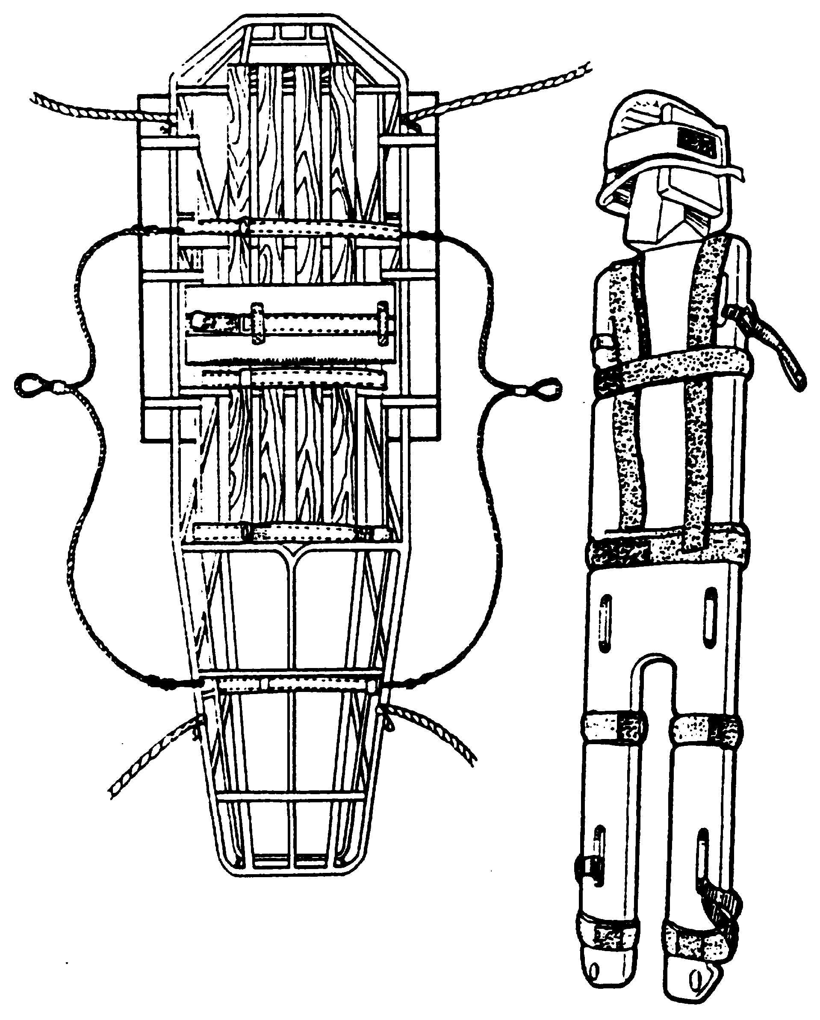stokes litter and miller board
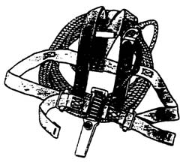surface swimmers harness

Water survival skills that should be utilized to increase the chances for surviving cold water immersion include:
Immediately upon entering the water, become oriented to the surrounding area. Try to locate sinking boat, floating objects, and other survivors.
Try to board a lifeboat, raft, overturned boat (if floating), or other floating platform as soon as possible to shorten the immersion time. Body heat is lost many times faster in the water than in the air. Since the effectiveness of the insulation worn is seriously reduced by being water soaked, it is important to be shielded from wind to avoid a wind-chill effect. If able to climb aboard a survival craft, use a canvas cover or tarpaulin as a shield from the cold. Huddling close to the other occupants in the craft will also conserve body heat.
While afloat in the water, do not attempt to swim unless it is necessary to reach a fellow survivor or a floating object which can be grasped or climbed onto.
Unnecessary swimming will pump out any warm water between the body and the layers of clothing and will increase the rate of body-heat loss. Also, unnecessary movements of arms and legs send warm blood from the inner core to the outer layer of the body resulting in a rapid heat loss.
The body position assumed in the water is very important in conserving heat. Float as still as possible with legs together, elbows close to your side and arms folded across the front of the PFD. This is called the HELP (Heat Escape Lessening Position) and minimizes exposure of the body surface to the cold water. Try to keep head and neck out of the water (see Figure 16-15). However, if wearing a Type III PFD, or if the HELP position turns the body face down, bring legs together tight and arms tight to sides and head back.
Another heat conserving position is to huddle closely to others in the water making as much body contact as possible. A PFD must be worn to be able to maintain these positions in the water (see Figure 16-16).
Avoid drown-proofing in cold water. Drown-proofing is a technique where the person relaxes in the water and allows their head to submerge between breaths. It is an energy saver in warm water when a PFD is not worn. If a PFD is not worn, tread the water only as much as necessary to keep head out of the water.
Keep a positive attitude about survival and rescue. This will extend survival time until rescue comes. A will to live does make a difference.

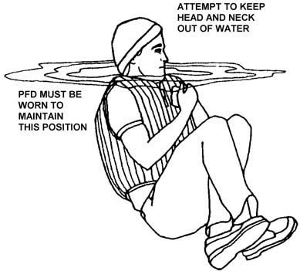
Figure 16-15 Single PIW
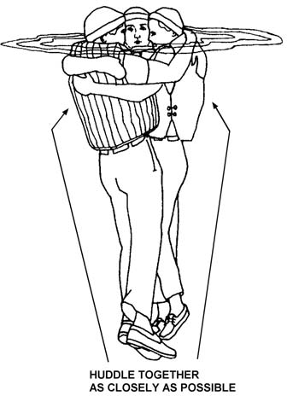
Figure 16-16 Multiple PIWs

Additional Information
Equipment review: https://theislander.net/in-water-rescue-equipment-techniques/
This rudimentary drawing shows how a line can be rigged to assist in retrieving someone. If they are fit and strong enough to life their leg high enough to place their foot on the line and then haul themselves up.
One end of the line could be on a winch to pull the line up. Clearly depends on the conditions at sea.
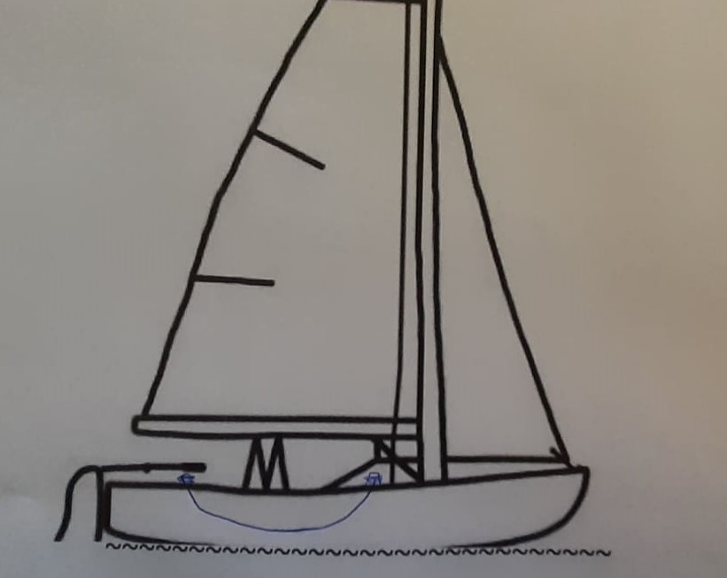
Additional line for person in the water to use to assist in climbing back on board
We have used a fender in the middle of a line such as this one, as a makeshift ladder rung. It was set up with a shorter distance between each end of the line attached to the vessel.

