Collision Regulations: Vessel Aground Lights and Shapes
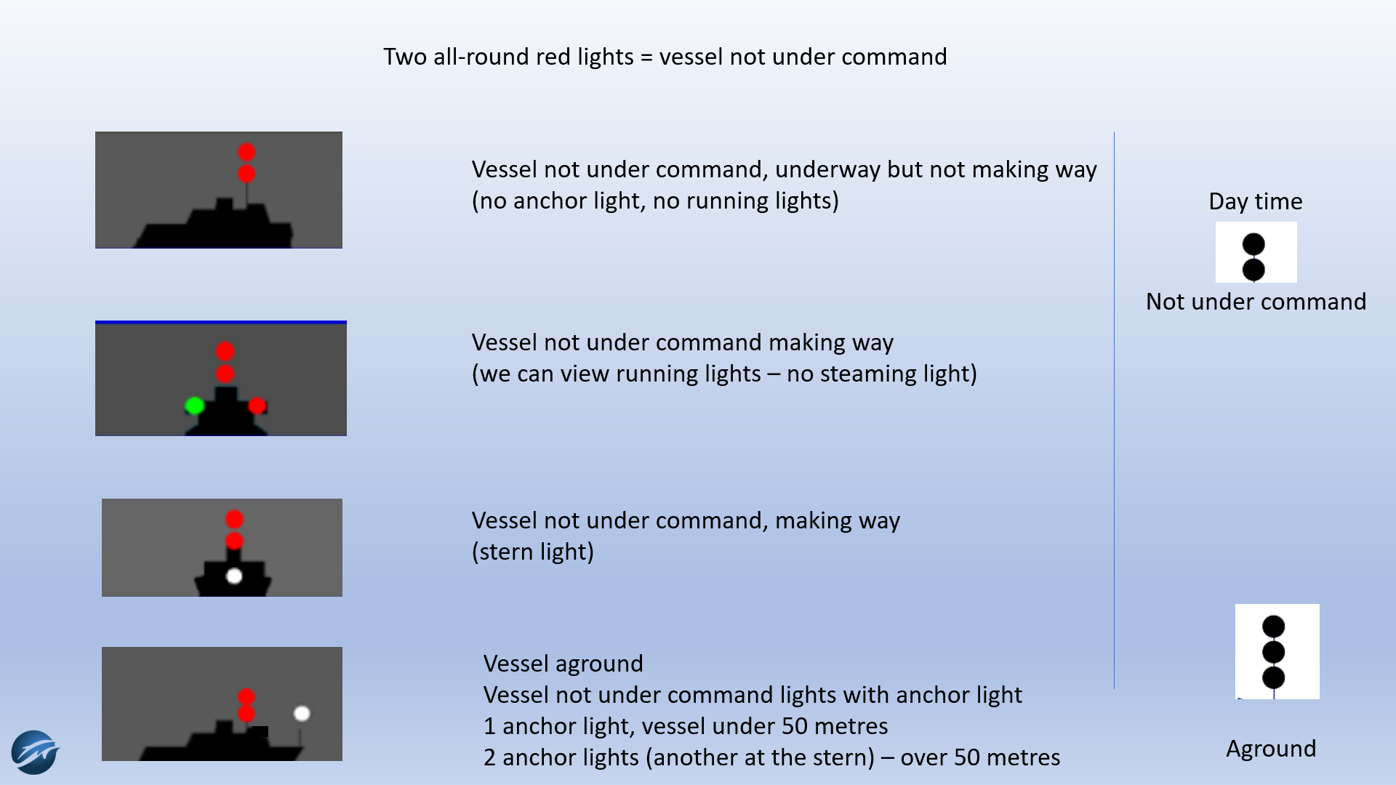
A vessel aground shall exhibit
Time of the day: From sunset to sunrise and from sunrise to sunset in restricted visibility
A vessel aground of less than 50 m in length shall exhibit:
- an all-round white light, where it can best be seen;
- two all-round red lights in a vertical line, where they can best be seen.
A vessel aground of more than 50 m in length shall exhibit:
- in the fore part, an all-round white light;
- at or near the stern and at a lower level that the light in the fore part, an all-round white light;
- two all-round red lights in a vertical line, where they can best be seen.
A vessel aground during the day
Three (black) balls in a vertical line.

