
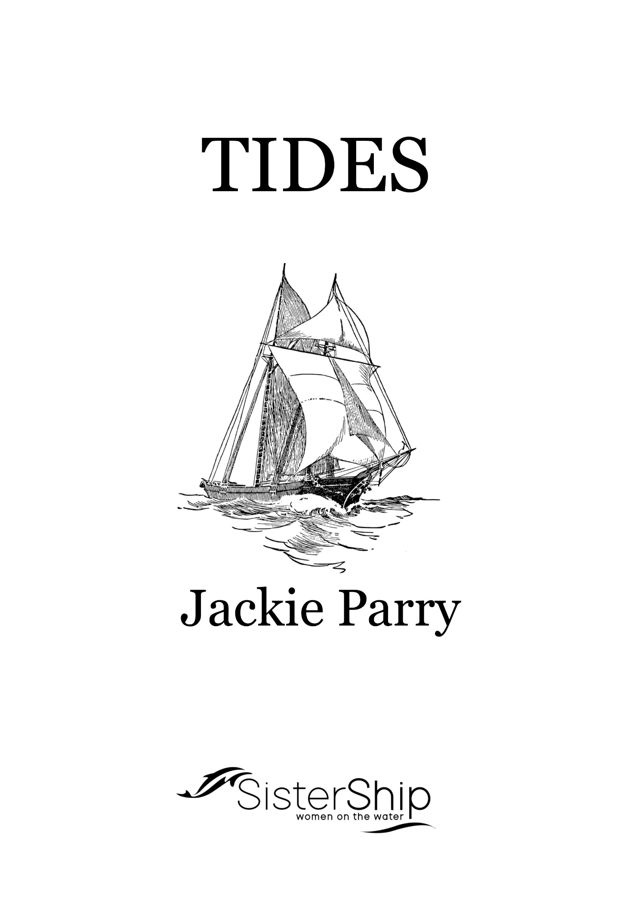

THE THEORY OF TIDES

What Causes Tides
The sun and moon have attractive forces, which cause tides. The moon is closer to the sun and therefore much more effective on the earth than the sun.

The moon orbits the earth approximately once every 28 days and largely controls the time of high and low waters. The relative position of the sun and moon determines whether the sun’s force increases or decreases the moon’s effect on the tide.

When the sun and moon are either in opposition or conjunction this is when spring tides result. This is when the sun and moon are working together to distort the envelope of water surround the earth. When the effects are not in line the sun and moon are in quadrature and neap tides are the result.

Opposition produces a full moon. Conjunction produces a new moon.

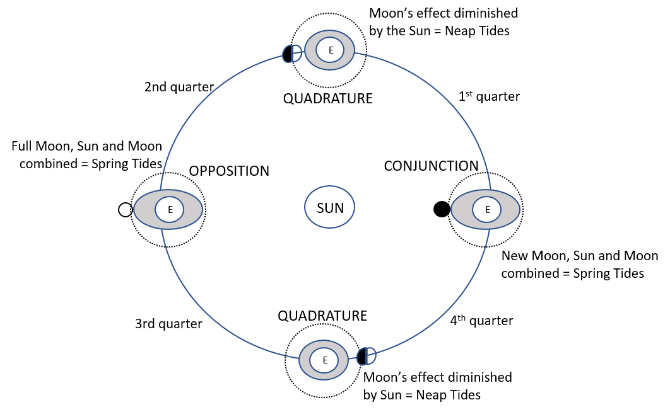

The Effect of Celestial Bodies on Tides

In this diagram, the shape of the envelope of water has been exaggerated. The actual rise and fall of tides in the middle of the oceans is not noticeable on board. However, on the coastline the effects are significant. The shape of the coastline also effects the tidal heights and patterns.

Low atmospheric pressure can increase the height of the tide and onshore winds ‘hold-up’ the tide. If an abnormal low atmospheric pressure system and onshore winds meet (ie a tropical cyclone) the effects can be devastating.

In maritime we have Chart Datum. Tides are complex, so tidal predications are created to provide a standard set of conditions. Chart datum is Lowest Astronomical Tide (LAT).

There are many other scientific constituents that affect the height and timing of tides. These are call Harmonic Constants. They include facts such as: the ocean has different depths at different locations, the Earth tilts 23° off the vertical, the Earth spins, continents have differing and odd shapes.

Tide Duration and Range
The Duration of Tide is the time interval between successive High Waters. Range of Tide is the difference in height between Low Water and High Water.

The Duration of the rise is the time interval from Low Water to High Water. The Duration of the fall is the time interval from High Water to Low Water.

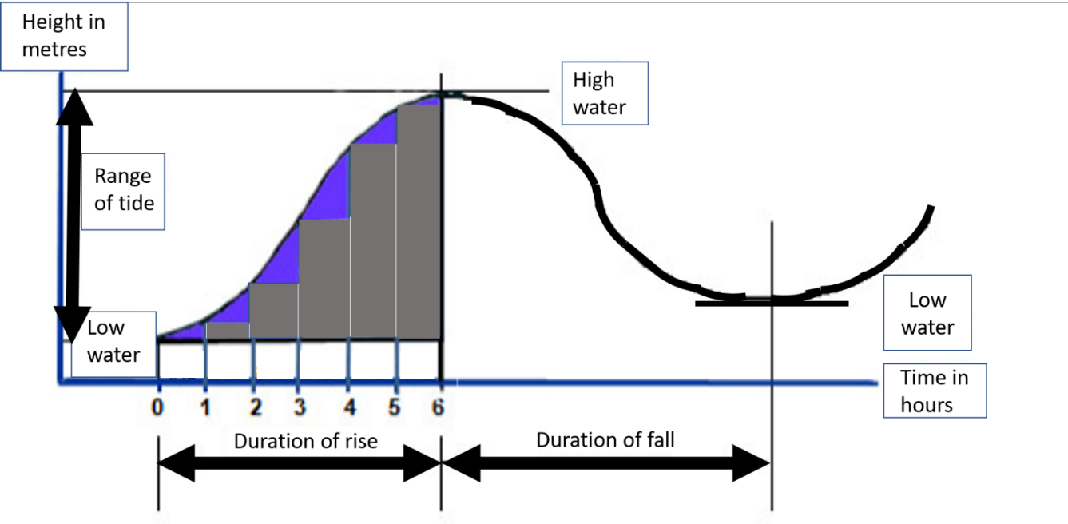

Standard Ports
Standard Ports are a reference station where predictions are based on continuous observations, including the changes in conditions due to meteorological conditions.

The information given in the Australian National Tide tables for each standard port is the predicted times and heights of high and low water.

Tide Tables Standard Port
Example: To find the time and height of high and low water at Hobart on 16th June 1996.
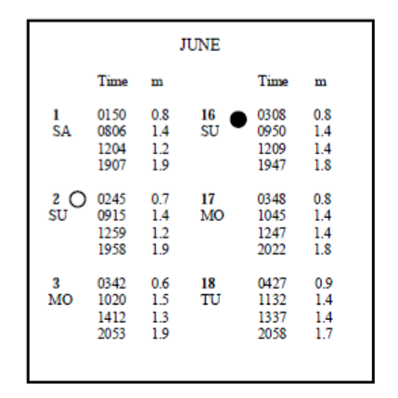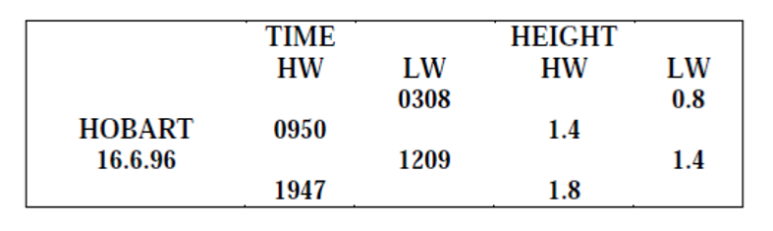

Note: There is no fall in tide in this example due to various reasons: some areas have only one tidal change daily due to variations in pull of celestial bodies, the different effects of gravitational forces, shape of coast line, etc.

Heights and Times of Intermediate Tides
You may need information on the Height of Tide at times other than High Water or Low Water.

For example:
- Depth of water available at your calculated time of arrival at port, there may be a shallow to navigate.
- Calculate the earliest time for sufficient under-keel clearance on a rising tide or falling tide.

To calculate intermediate tides, an easy method is to use From AH130. AH130 is an L-shaped graph. It is straightforward to use but you must take care with the plotting.

- The uppermost part of the time scale graph is High Water
- You extract the High Water time when looking at a falling tide (plotted at the top of the time scale graph).

- You extract the Low Water time when looking at a rising tide (plotted at the bottom of the time scale graph).
- Scales: If the height of High Water is 5 metres or less, you must use the larger of the height scales. If the height of High Water is larger than 5 metres you must use the smaller of the height scales.
- NEVER mix up the two scales
- Be cautious when plotting decimal fractions.

Intermediate Heights Example:

Using the Tide Table Extract for Gladstone and Form AH130, find the Height of Tide for Gladstone at 0700 hours on the 20th May.

From the daily predictions, the Times and Heights of Tide on either side of 0700 for the morning of that date are:

0231 3.7m (HW)
0914 1.2m (LW)

Form (AH130) provides instructions.
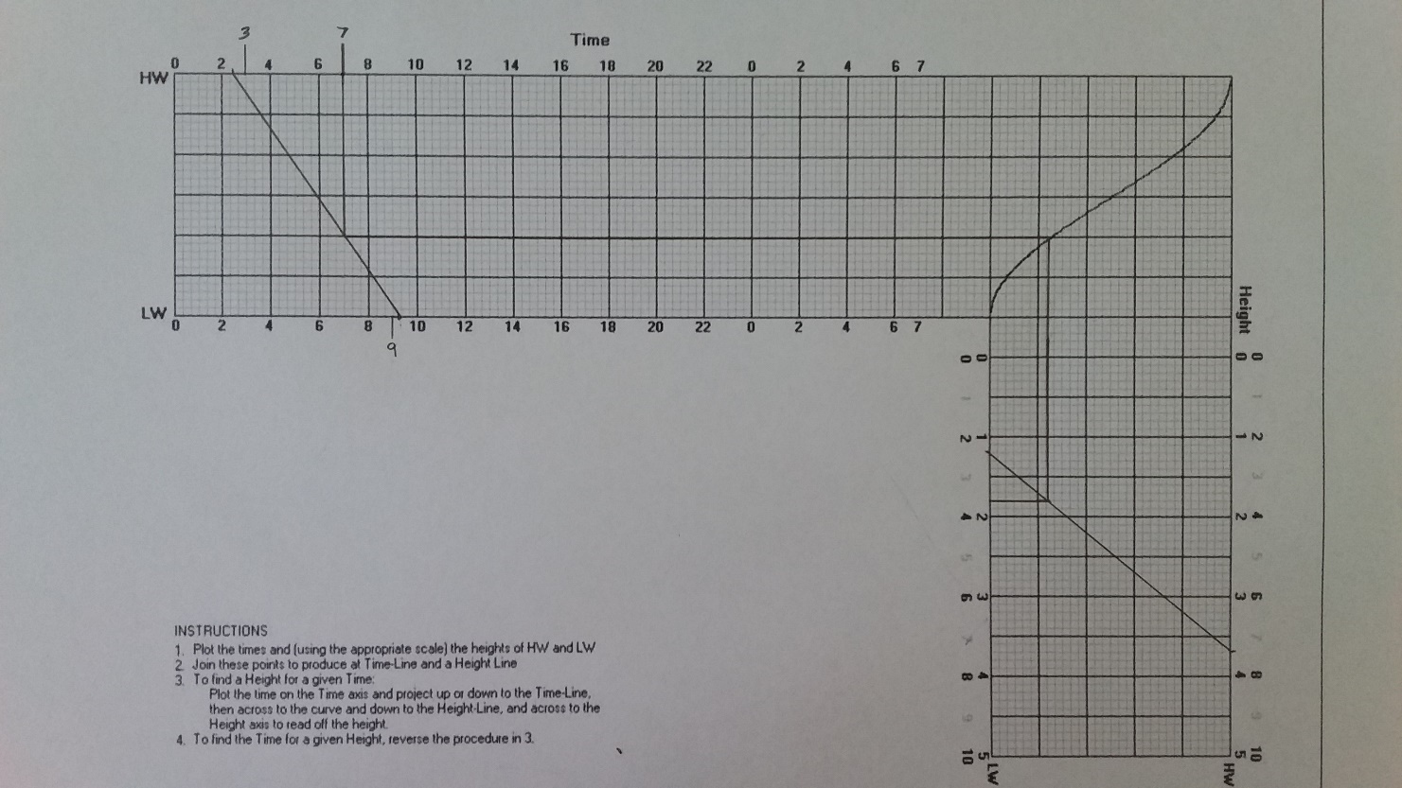
Your height of tide at 0700 hours at Gladstone will be 1.8 metres.

