Ways to free your boat: Running aground
If you ground at the very bottom of the tide, are in a calm situation, grounded slowly the vessel should reverse easily. The tide will rise to lift the vessel up too. Or if there is a quick way to deploy the anchor in the right position you can kedge off (or kedge out).
Using the engine
Caution must be applied as your water intake could be near the sea bed and potentially suck up harmful objects.
1) Put the helm hard over to steer towards the channel (deeper water)
2) Heel the boat towards the near bank as much as you can by leaning or sitting on the out stretched boom (if on a sailboat) or on the toe rail
3) Apply full ahead propulsion.
The vessel will probably not move ahead but it may pivot. If this works it will pivot until it points in the direction it came.
Kedging Off
In calm conditions you may be able to and move the vessel by using anchoring equipment.
1) Launch the tender (dinghy) and take your anchor out into deeper water.
2) Carefully drop the anchor
3) Return to the vessel and slowing winch or pull on the anchor until it holds
4) Continue to pull your vessel forward via the anchor, into deeper water
5) If you have not stowed your dinghy away (davits or on deck) be cautious of your painter (any lines) in the water when manoeuvring, especially when you start your engine.
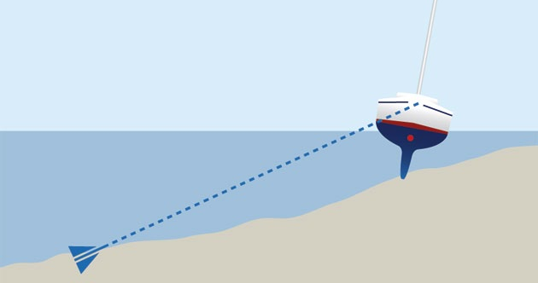
Kedging Off

Additional Options for Sailboats
To cause a vessel to heel over:
1) Swing a weighted/loaded boom out
2) Hoist a sail in a beam wind
3) Ask another vessel to take your main halyard and pull the mast/vessel over
Caution
If you do free your vessel quickly, carefully check the hull internally for leaks before doing anything else. Be ready to put her back up if there is substantial damage.
If you are stuck stabilise the vessel and assess your situation as best you can
If you are on a falling tide, transfer weight into the bottom of the vessel and try to deploy
the ground tackle (anchor).
If you are in a seaway and you are not ready to act, an option is to deploy the anchors out as best you can.
You must try to stop the vessel going further onto the reef wherever you are aground.
If possible, avoid the end of result of your location drying out and the mast leaning towards the deeper water, as the boat will be at a more extreme angle and may well risk flooding when the tide returns.

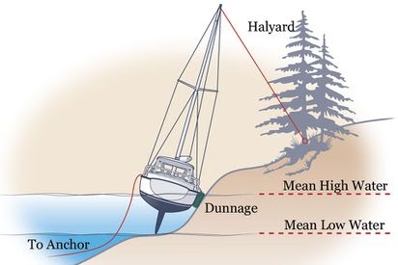
Stabilising your vessel is one option, if possible

