True to Compass (or Compass to True)
If you have found the course to steer on your chart, that will be in True. The helmsperson needs a Compass course to steer by, therefore you need to convert True to Compass.

Variation
In most parts of the world there is Variation. Variation changes with position, e.g. in the eastern Mediterranean Sea, Variation is minimal, but in the central North Atlantic, Variation can be much more. Moreover, some places will have a westerly Variation and some an easterly Variation.

In addition to the changes in Variation due to position, the Variation amount also changes over time (in the same position/area). This occurs because the position of the Magnetic North Pole slowly moves in a small circle. The movement of the Magnetic North Pole is known as Secular Variation or Secular Change and is indicated in the compass rose.

The Secular Change is indicated by the figure in brackets, next to the current Variation on the compass rose on your chart.

Example - Variation:

8°20ʹE 2014 (1ʹW) (from Chart AUS252)

This means that in 2014 the Variation was 8°20ʹE. Every year, thereafter, it moves 1ʹ West.

From 2014 until 2020 = six years.

Therefore, apply 6ʹ West to 8°20ʹ (i.e. one minute for each year).

You start with 8°20ʹE, apply 6ʹW = 8° 14ʹ E (it’s easier to see in diagrammatical form):
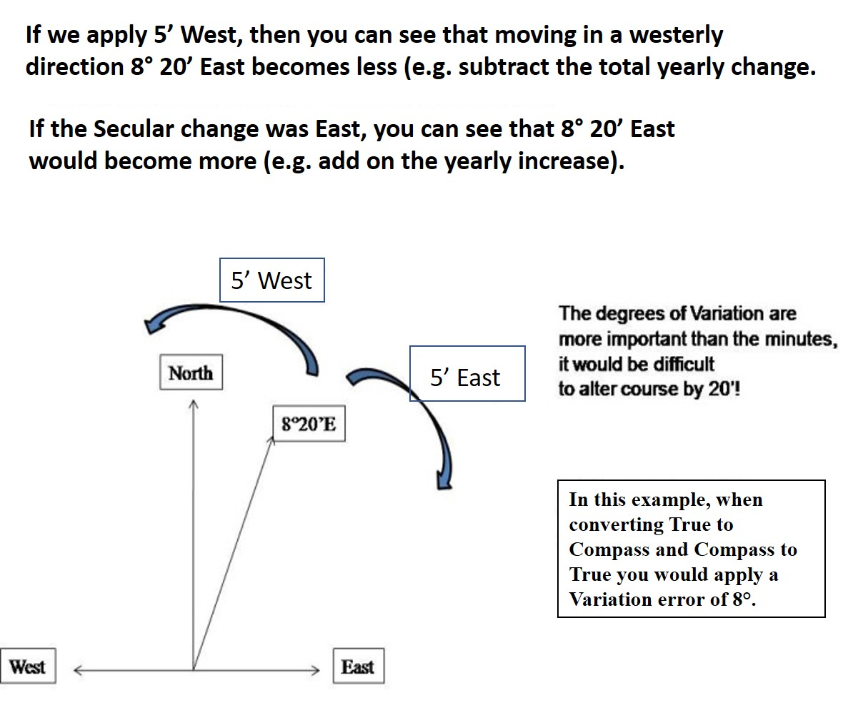
The degrees of Variation are more important than the minutes, it would be extremely difficult to alter course by just 14’
6’ East
In this example, when converting True to Compass and Compass to True you would apply a Variation error of 8°E.
6’ West
If we apply 6’ West, then you can see that moving in a westerly direction 8° 20’ East becomes less (e.g. subtract the total yearly change).

More Variation Examples
1)
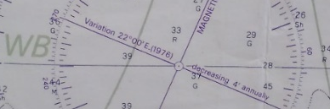

Answer: Variation for 2020 = 19° E

Calculation:
44 years (difference between 1976 and 2020) x 4’ = 176’

How many whole degrees make up 176’? = 3° = 180’ (this is within 4 minutes (‘) of 176’ and definitely close enough to steer by.

Therefore, we have 3° to subtract (West = subtract: the chart compass rose tells us the variation is decreasing).

22°E - 3°W = 19° E

2)
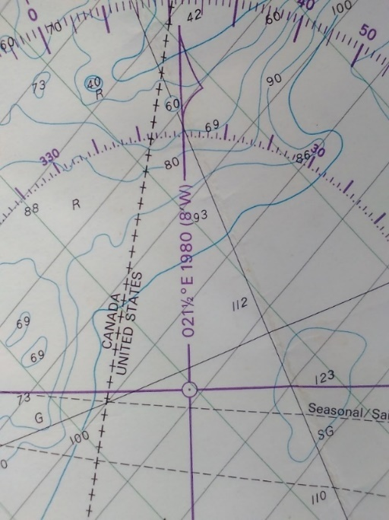

Answer: 16°E
40 years (difference between 1980 and 2020) x 8’W = 320’ minutes

320’ / 60 (1 degree) = 5° 20’

Take care with the remaining minutes.
You’ve calculated that there are 5° in 320’

5 x 60 = 300, so you have just 20 minutes left (320 – 300).

Adjusting your Variation to 2020, as follows:

21° 30’E - 5°20’W = 16° 10’E

Round down to 16°E

TIP: Draw it out. A visual aid helps confirm you are on the right track.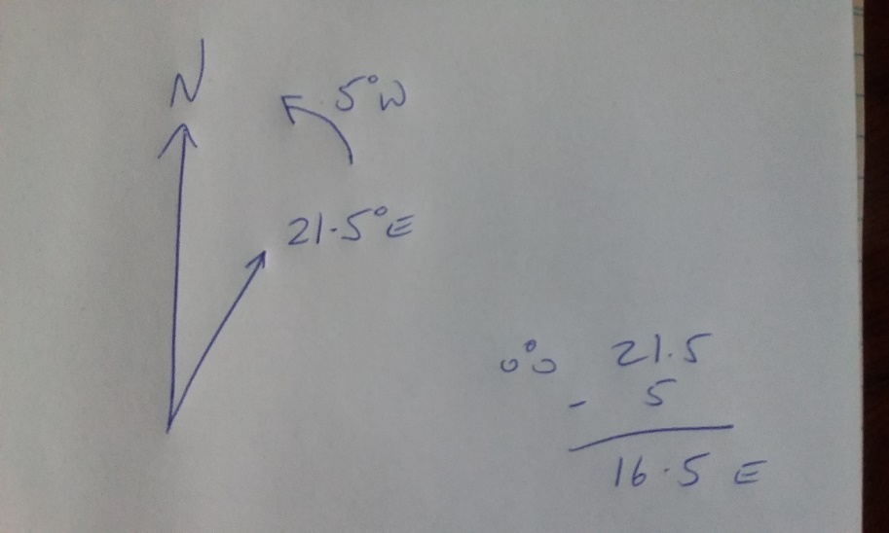
Therefore:
21°30’E
-5°20’W
------------
16°10’E
21°30’E
5° 20’W

A rather crude sketch, but it helps to see what is actually occurring.
3)
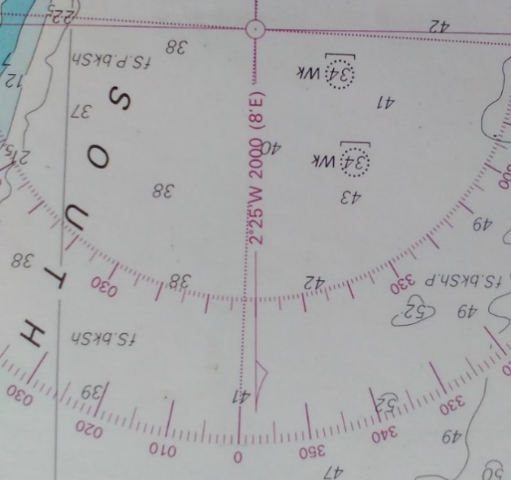
Answer: 1°E
2°25’W 2000 (8’)

Calculate answer:
20 years x 8 = 160’

There are two whole degrees in 160 minutes, plus 40’
2 x 60 = 120

We had 160 minutes, we subtract 120 minutes (as that is 2 degrees) and we are left with 40 minutes, that is close to another whole degree. Due to the vessel yawing, rounding up in this situation is fine: 3°E

We are adding on the East figure, therefore, looking back at our chart.
2°25’W plus 3°E = 0°35’E (again disregard the minutes), so our answer is 1°E

If you are finding this part tricky, you can turn the degrees into minutes to use simple mathematics. Starting with a negative (West) is harder.

Simplify where you can: There are 60 minutes in a degree, therefore:
2°25 is the same as 145 minutes
3° is the same as 180 minutes

180 – 145 = 35’E.
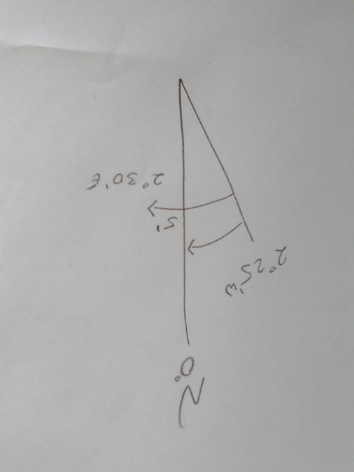
Gives us 1° E Variation for 2020
3° E adjustment applied to the Variation in 2000

Converting True to Compass and Compass to True

If you use a hand-bearing compass, there will be no known Deviation (Deviation is the second error). Deviation is caused by magnetic material onboard altering the compass point by so many degrees and only applies to your ship’s compass.

To convert Compass to True or True to Compass there are two useful memory aids to utilise.
First, write down the key points:

CAN C Compass (your boat’s steering compass)
DEAD D Deviation (from your boat’s Deviation card, created by Compass Adjuster)
MEN M Magnetic (Ship’s Compass with Deviation applied or Hand Held Compass)
VOTE V Variation (found on your chart, always either east or west of true north)
TWICE T True (all chart work must be in True)

(Or, Tele Vision Makes Dull Company, which are the above letters in reverse.)

