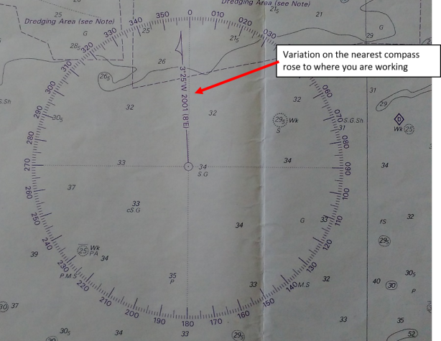

From 2001 to 2020 there are 19 years. For each year the Variation has changed by 8’E, therefore:

8 x 19 = 152’

We know that a degree is 60 minutes and two degrees is 120 minutes, with 32’ left.

We therefore have a change in Variation of 2° 32’E (between 2001 and 2020).

The Variation in 2001 was 3°25’W (in the rose) and you can see in the picture above that it is West (left of 360°) and therefore considered a minus.

If the amount of change in the Variation (2001 to 2020) is East, then we add the calculated 2°32’E.

-3° 25’W + 2°32’ E = 0° 53’W

In Variation calculations think of West as a minus, illustrated in the following diagram. We can round up to 1°W

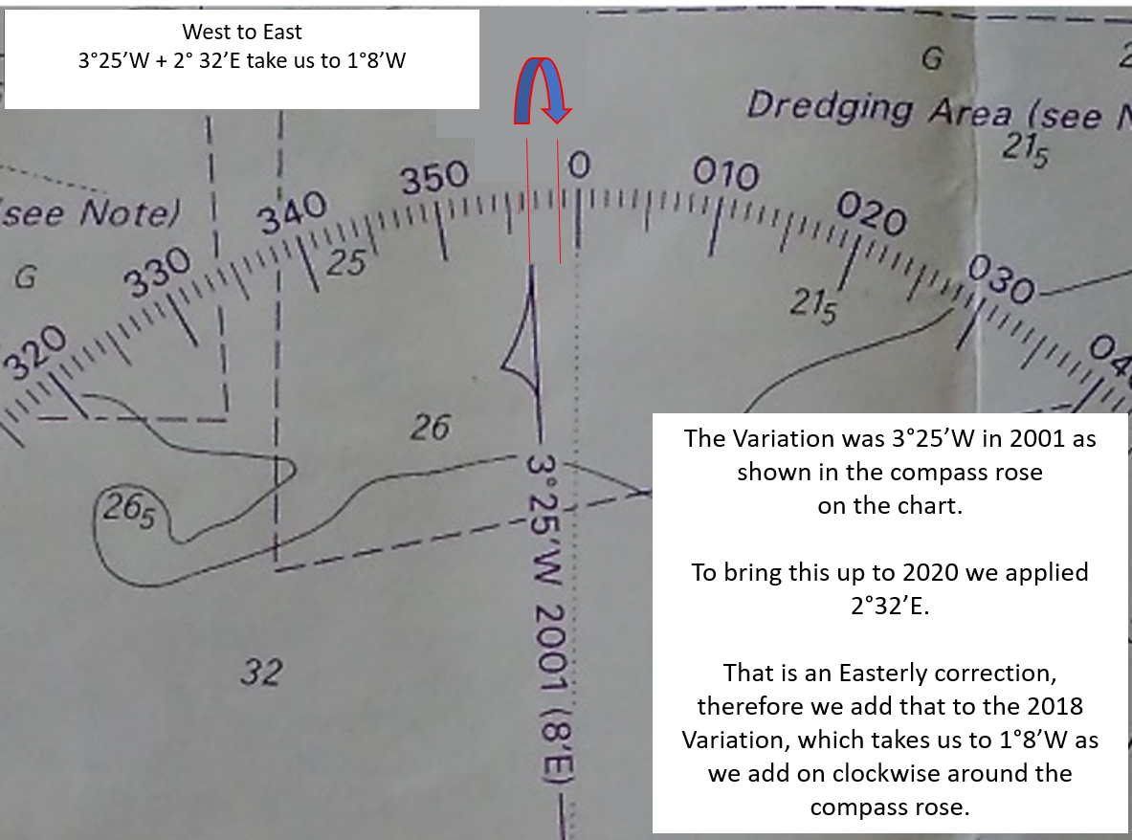
That is an Easterly correction, therefore we add that to the 2018 Variation, which takes us to 0°53’W as we add on clockwise around the compass rose.
West to East
3°25’W + 2°32’E takes us to 0°53’W

It is impossible to steer by minutes, so we’ll use 1°W as our Variation.
Now we can convert our Compass bearings to True for our chart work.

Deviation? Remember, there is NO deviation applied to a handheld compass. The Deviation card on board is for the ship’s Compass only. Moving a handheld compass around the vessel will mean the compass has different readings for Deviation. It’s good practice to try to be as far as possible from magnetic items on board (without falling overboard!).

Write out the conversion for three magnetic bearings 82°, 51°, 24°, taken by the handheld compass:

C (this is the ship’s compass which we didn’t use)
D (there is no known deviation as we used a handheld compass)
M 82° 51° 24° (handheld compass bearings)
V 1°W 1°W 1°W (error West compass or magnetic Best)

T 81° 50° 23°

These True bearings can be drawn on the chart.

